Software for ELEN 479 Automatic Control Systems Lab

If you already have MATLAB installed you may skip to step 8.

- Go to mathworks.com, go to Get MATLAB, and create and account with your school email.

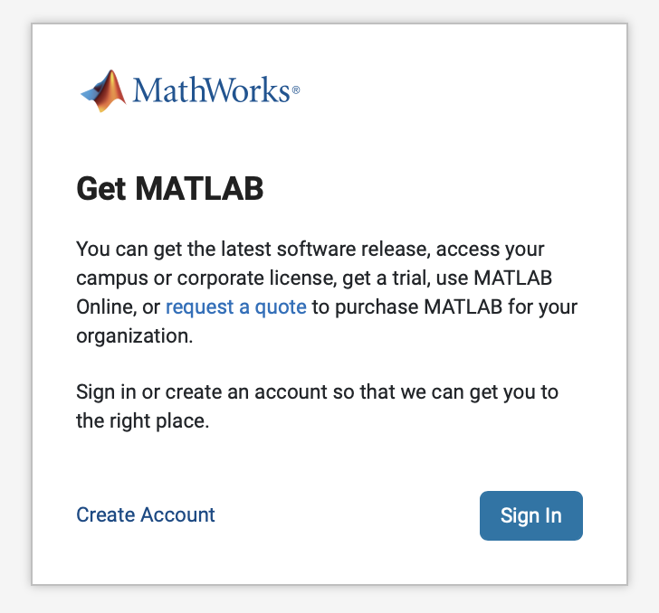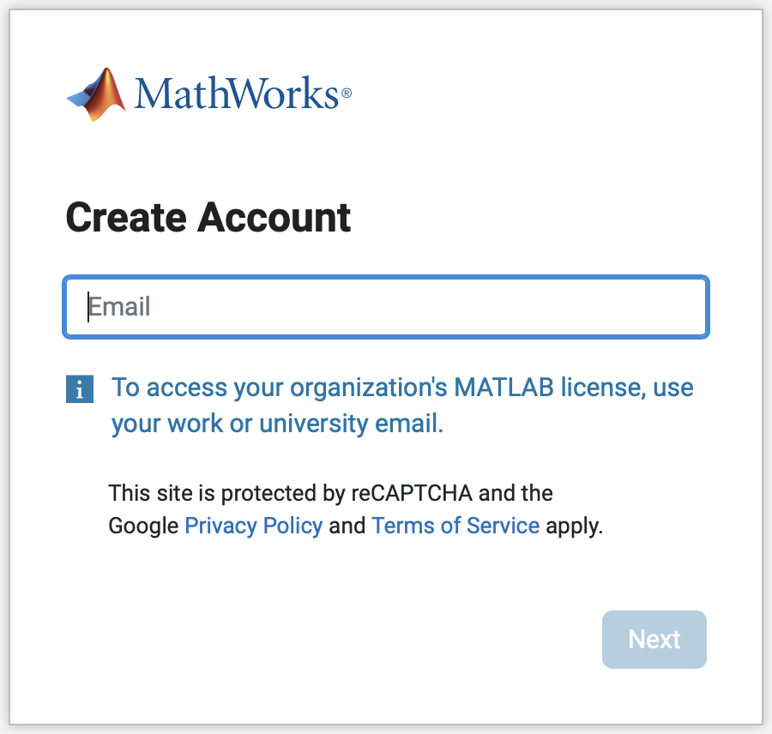

- Once you’ve created your account and logged in, you’ll press Install MATLAB and reach the downloads page. Download the most recent version of MATLAB
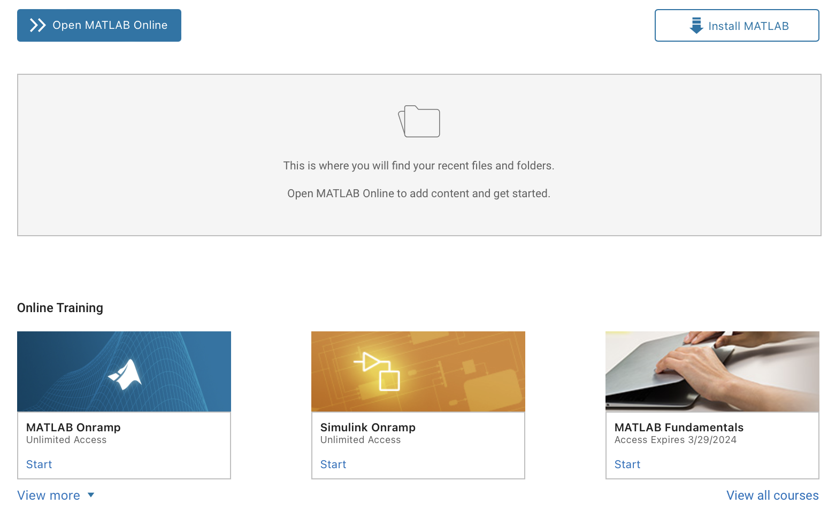
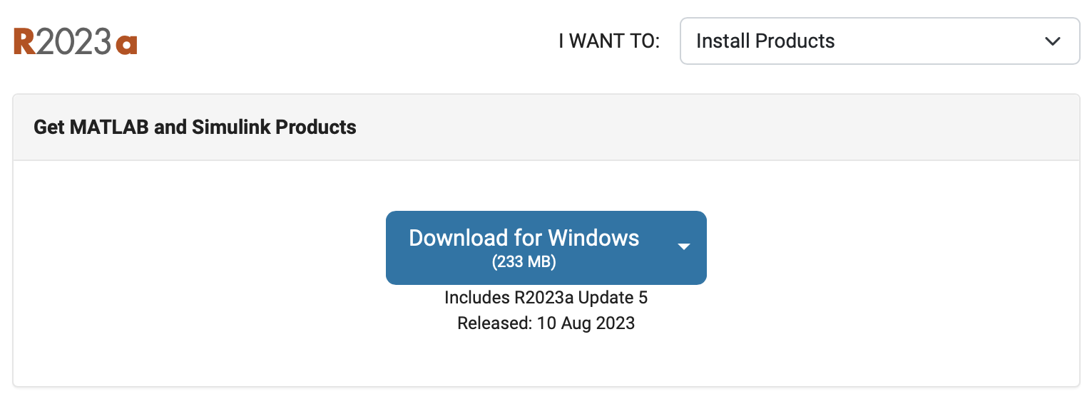
- Once the installer is downloaded, open it. You will be at another log-in screen. Log in.
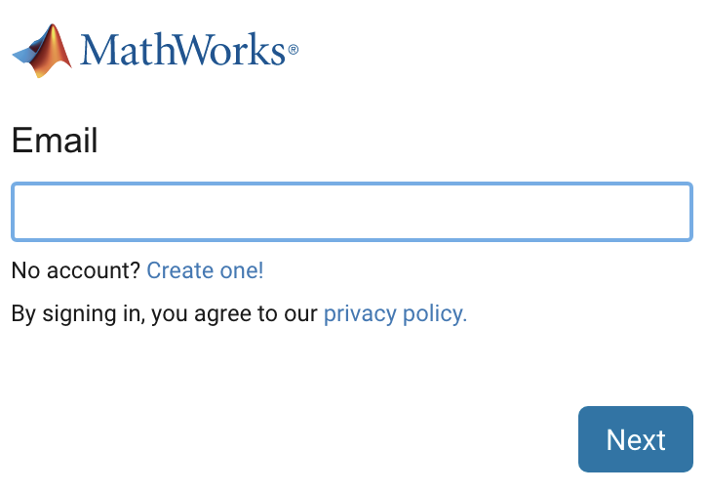
- Blah blah blah terms and conditions, sign your soul to the devil.
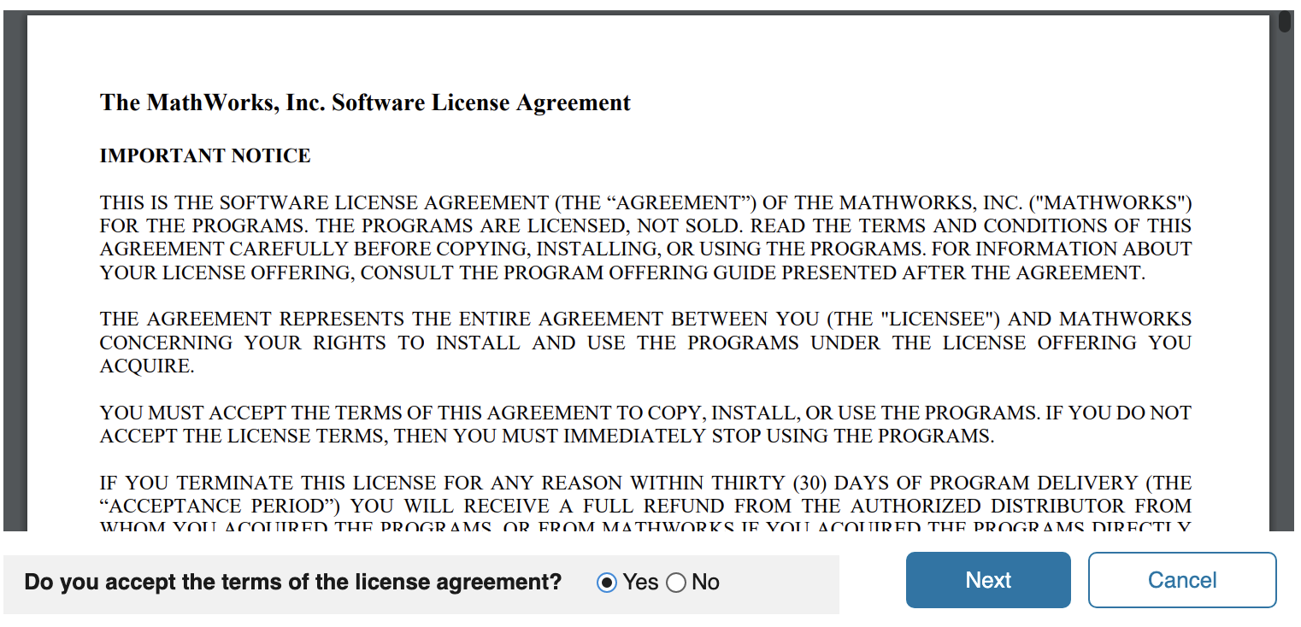
- It will give you a license. Press next. It will ask you to confirm user. Press next.
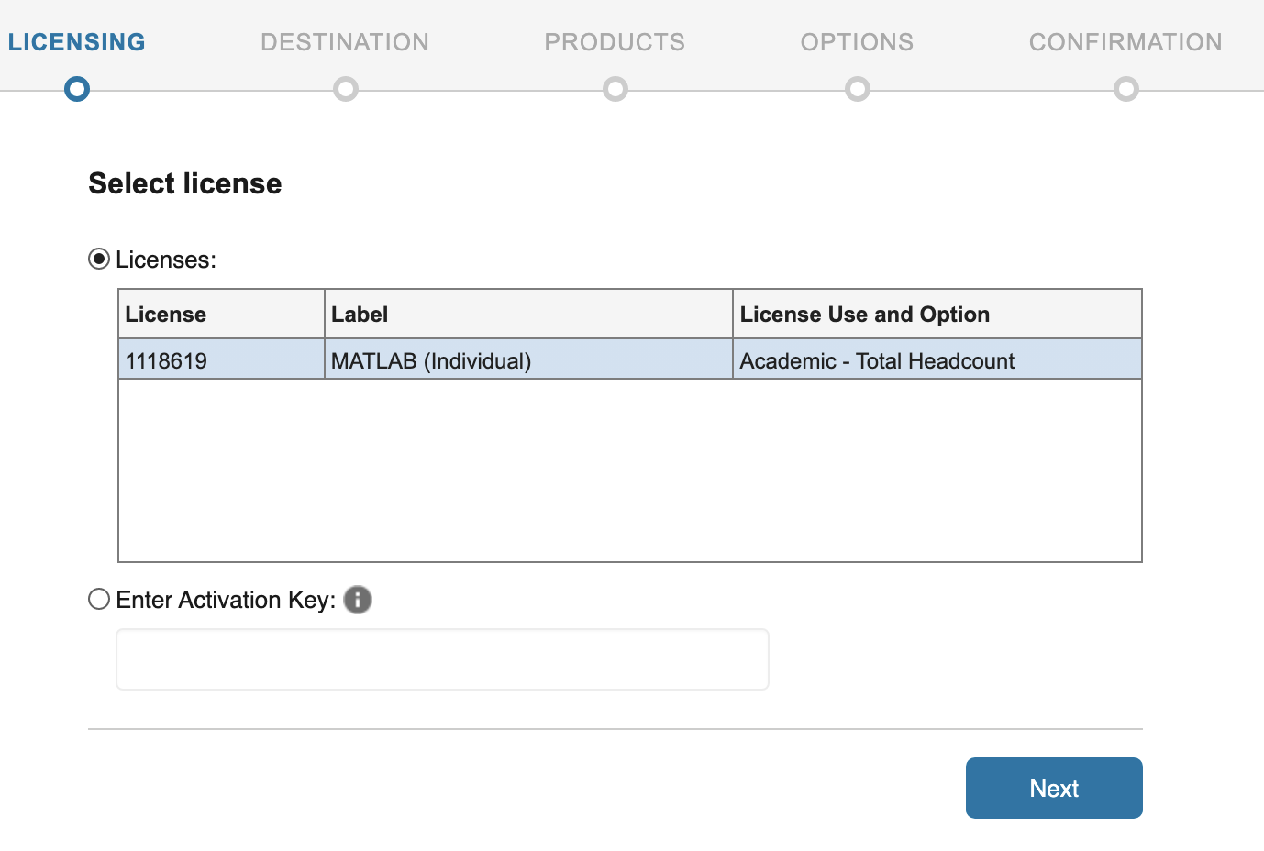
- It will suggest a default destination folder for your installation. Go with that.
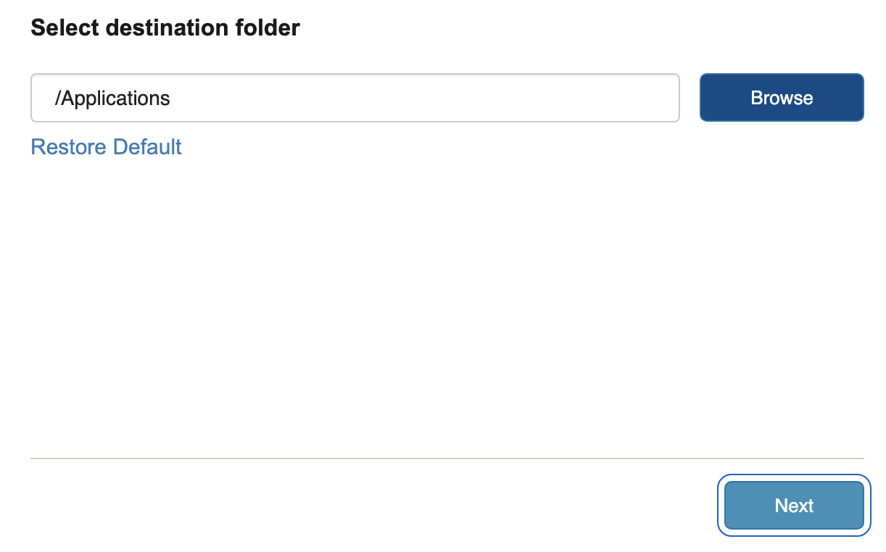
- In addition to MATLAB, select Simulink and the Control Systems Toolbox. Press next again until it lets you begin install.
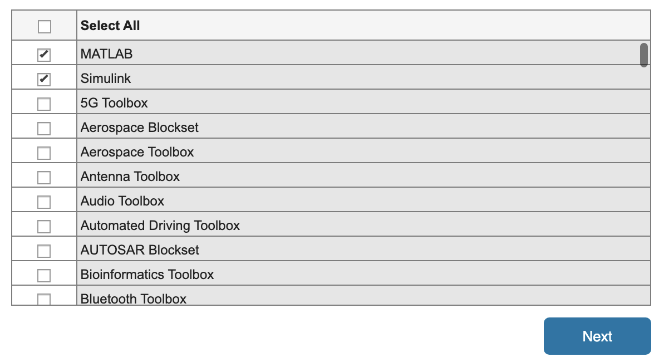

- To make sure you have all the ad-ons needed for this class, go to the environment section in the Home Tab and select Get Add-Ons.
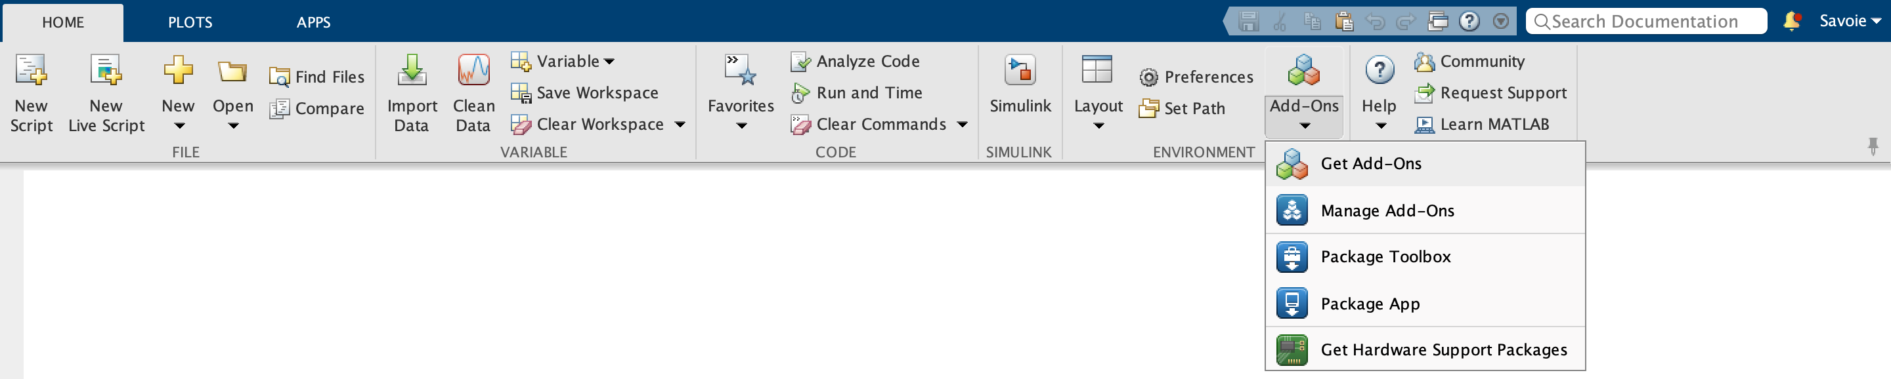
- Install the MATLAB Support Package for Arduino Hardware, as well as the Controls ToolBox and Simulink if you do not already have them installed.
